CardioFlex
User Guide

Table of Contents
1. Overview
2. List of Files in the GitHub Repository
3. Versions of CardioFlex
4. Front Panel
5. Input Data File Formats
6. Analysis of data with 8 stretches
7. Analysis of data files with no stretches or fewer than 8 stretches
8. Summary Tab
Section 1: Overview
CardioFlex is designed for mechanical testing of engineered muscle tissues or small intact muscle preparations. The application can handle a variety of different file formats (see Section 5 below) that include columns for time, force, length, and stimulus. The application can extract the active/passive force as a function of length, contraction/relaxation velocity, time for contraction/relaxation, force integrals, beats per minute (bpm), and heart rate variability. Furthermore, output data from multiple files can be combined and summarized using this program.

CardioFlex is described in the manuscript by Modak et al.

Section 2: List of Files in the GitHub Repository
All the files necessary to run CardioFlex, the user guide, and sample data can be found in the GitHub repository.

This repository is located at XX.

The repository contains the following folder and files:

CardioFlex_WinInstall.exe Standalone version of CardioFlex for Windows. Installs both the MATLAB runtime necessary to run CardioFlex and CardioFlex.exe.
CardioFlex Application
CardioFlex_MacInstall.XX Standalone version of CardioFlex for MacOS. Installs both the MATLAB runtime necessary to run CardioFlex and CardioFlex.exe.
CardioFlex.mlapp MATLAB-based version of CardioFlex. This requires MATLAB and the necessary toolboxes (Section 3).
CardioFlex_PyGUI.py Python-based version of CardioFlex. Note that this version appears slightly different than the MATLAB-based version; however, all functionality is conserved.
CardioFlex_Core.py Necessary accessory file for the Python GUI.
CardioFlex_Requirements.txt Requirements for running the Python GUI.
Python_README.txt Commands for bash terminal to run the code.
CardioFlex_raw_code.txt Text of the MATLAB code that can be read in a text reader.
User_Guide.pdf The user guide that you are reading now.
Sample_Data_Control.dat Sample input data for control EHT.
Sample_Data_Mava.data Sample input data for a mavacamten-treated EHT.
Sample_Data_Iso.data Sample input data for an isoproterenol-treated EHT.
Sample_Output_Data (folder) Sample output data – one .txt file, two .csv files and ten .eps and .png files.

Section 3: Versions of CardioFlex
The MATLAB Version of CardioFlex
The MATLAB version of CardioFlex, CardioFlex.mlapp, was written in MATLAB 2025b. The program has been tested in MATLAB versions 2025b will be compatible with all the versions released after that. Executing this requires an active MATLAB license and the following Toolboxes:

- Signal Processing Toolbox
- Financial Toolbox
- Curve Fitting Toolbox
- Fixed-Point Designer

The advantage of executing .mlapp is that the code can be readily modified by the end user.
To open this version in MATLAB:
- In the Home tab next to word ‘File’, click on the small icon or ‘Browse For Folder’. Set the directory to the directory where you want to save your files.
- Click ‘Open’ from the Home menu in MATLAB.
- Locate the file named ‘CardioFlex.mlapp’ and double-click to open.
- The App Designer module of MATLAB will open. On the Designer menu, find the green button labeled ‘Run’. This will open the graphical user interface (GUI).

Standalone Version of CardioFlex
- Users will need to download and install MATLAB Runtime Compiler (MRC) appropriate for your Windows/Mac OS. It could be found here:
https://www.mathworks.com/products/compiler/matlab-runtime.html
- The compiled, standalone version of CardioFlex does not require a MATLAB license; however, it is not possible for the user to modify the code of this program. You can run the CardioFlex.exe once the MRC is installed.
OR
- The Windows installer is named CardioFlex_WinInstall, while the Mac installer is named CardioFlex_MacInstall. The installer will automatically download the MATLAB runtime necessary to run the program and install the CardioFlex application.
- While installing the application through this ensure to change the default location of CardioFlex to a folder on the local computer if you are not the admin. Default location of C:/Program Files/ will not allow the function to run or store output data.
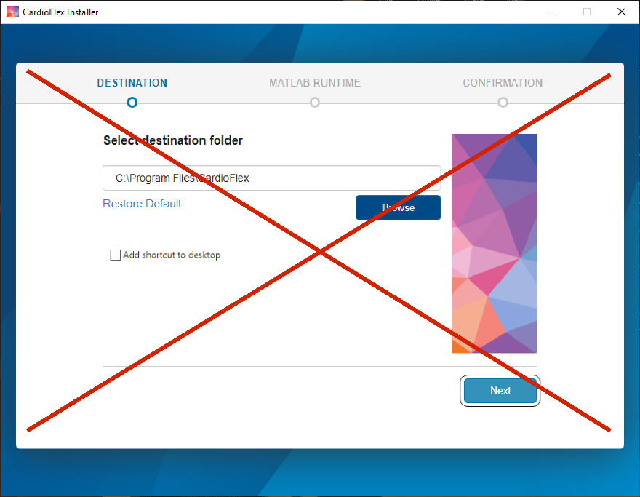

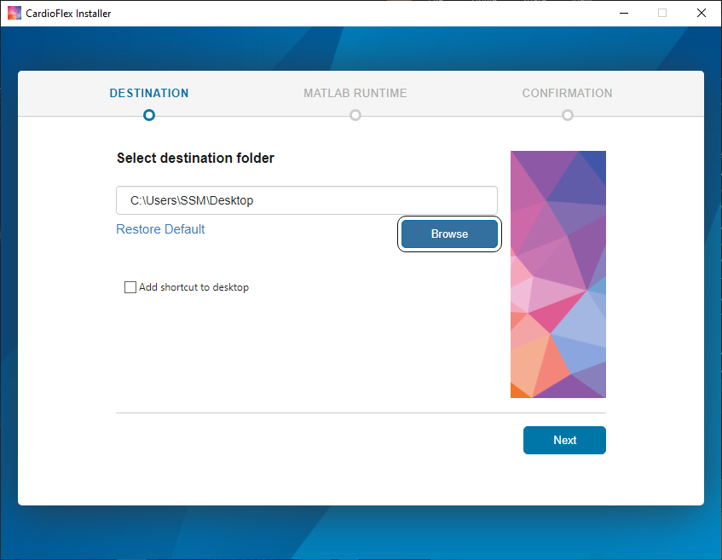

Python-Based Version of CardioFlex
AI (Claude 5) was used to convert the MATLAB GUI to a Python GUI.
There are 3 files for the Python GUI that need to be in the same directory. These are CardioFlex_Core.py, CardioFlex_Requirements.txt, and CardioFlex_PyGUI.py. The package requirements for CardioFlex can be found in the Python_README.txt file. To ensure that these packages are installed, open command line on your system and run the command:
pip install -r CardioFlex_Requirements.txt
Then open the CardioFlex_PYGUI.py file in a Python environment (e.g., Spyder) or run the following command:
python CardioFlex_PYGUI.py
This will open the GUI. Note that the front panel for the Python GUI will look slightly different than the MATLAB-based GUI; however, the functionality is the same.

Code
The MATLAB code for CardioFlex can be found in the text file CardioFlex_raw_code.txt. This is not executable on its own; however, the user is free to modify and use this code as they see fit.
Section 4: Front Panel
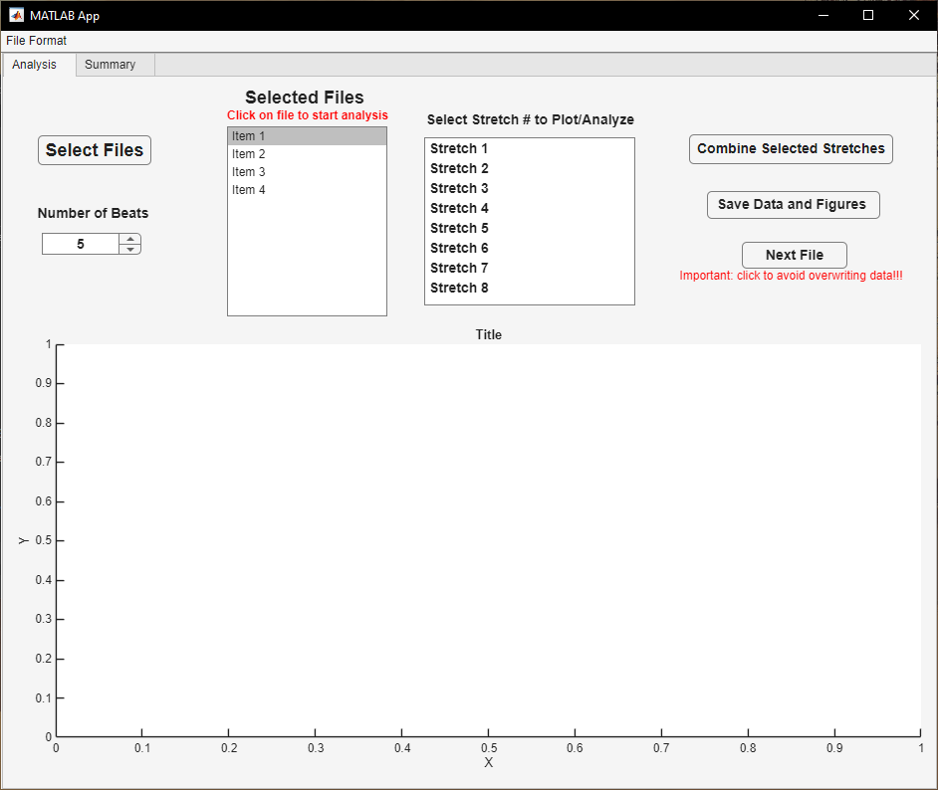
Figure 1: CardioFlex front panel
When the program opens, the front panel will become visible. The two tabs are ‘Analysis’ and ‘Summary’.
The ‘File Format’ button on toolbar and options are discussed in Section 5 and Summary tab is discussed in Section 8.

The buttons on the ‘Analysis’ tab are:
Select Files Button – Clicking on this button allows the user to select the files that will be imported for analysis. Note that multiple files can be selected at one time.
Number of Beats – Allows the user to specify the number of beats per stretch that will be averaged for the downstream analysis. Users can change the default ’5’ to any number.
Selected Files List Box – After selecting files, this list box is populated with the names of files imported for analysis. Users can click on the name of a given file to start analyzing that file.
Select Stretch # to Plot/Analyze – This lists the individual stretches identified in the file highlighted in the ‘Selected Files List Box’. As described in Section 5, by default, these stretches are automatically detected; however, it is also possible for the user to manually define the stretches. Users can select the stretch they want to analyze by clicking on its name in the list.
Combine Selected Stretches – After analyzing all the stretches in the selected file, the user can click this button to consolidate data from all the stretches.
Save Data and Figure – Saves output files and figures. Data is saved as a ‘<data_file_name>_output.txt file in the current director, while figures are saved in a subfolder titled ‘<data_file_name>_Output created in the current directory. Both .png and .eps versions of the figures are saved.
Next File – Once the user has completed analysis of a given file and saved the desired data, clicking this button will clear the current workspace and figures to avoid overwriting existing files with the new data.
Figure box – This is populated once a stretch is selected. It shows the force versus time trace for the selected trace in blue, the locations of stimuli in orange, and the number assigned to each beat.

Section 5: Defining the Input Data File Format
CardioFlex can read a variety of delimited text (.txt) or comma separated value (.csv) files, including Aurora instrument specific files (.dat). A typical file will have a header containing metadata followed by the experimental data in columns. The program requires columns for time, length, force, and stimulus; however, the order of these columns can be defined in the program. Sample data files can be found in the GitHub repository in the directory.
Note that the program does not read the header, and it assumes that time, force, and length have units of ms, mN, and mm respectively. If the data file has different units, then the user will need to either manually convert their data into these units before analyzing or manually convert the final output files into their units.
Also note that the user should count the line number from the beginning of the file (including the header) when defining these parameters.
The program has built in default parameters (described below); however, the user can alter these values to fit their specific data. Before analyzing data, the user needs to define their specific data file format into the program.

Click the ‘File Format’ tab:
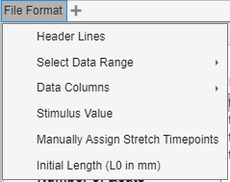

Figure 2. File format menu

Here are several options you can set:

- Header lines: This is the number of non-data/header lines at the beginning of a file before the numerical values in data columns (our files have 265 lines, so this is the default). Typically, headers include metadata about the instrument, calibration, protocols used for testing, data column headers/names etc. CardioFlex needs to skip these lines and start reading in the first row containing numerical values. Users can select File Format>Header Lines and then enter the number of non-numerical lines that will be skipped.

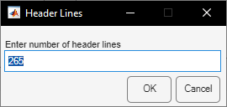

Figure 3. Header line selection dialog

- Select Data Range: This allows the user to define the line numbers for the start and end of the data to analyze. This allows the user to remove the preconditioning at the beginning of a protocol or excess data at the end of a protocol. By default, the program reads data starting from line 165265 and ending at line 700265. It is recommended to include at least 5000 lines before first stretch and 5000 lines after last stretch.

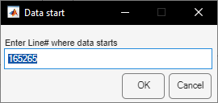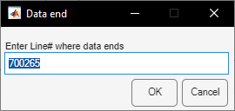
Figure 4. Data range selection dialog

- Data Columns: This allows the user to define which columns contain which data. The application requires data for: ‘Time’ (in ms), ‘Length’ (in mm), ‘Force’ (in mN), and ‘Stimulus’ (TTL signal for pacing). Note that if different units are used, the user will need to manually modify the program code or their data. By default, these are columns 1, 2, 4, and 9, respectively to match the sample data. The user can set the column numbers by clicking File Format>Time/Length/Force/Stimulus.

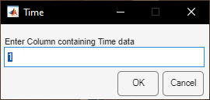

Figure 5. Data column selection dialog

- Stimulus Value: The program identifies the peak that follows an electrical stimulus, and the stimulus is used to align individual beats for averaging. Electrical stimulation event should be defined by a value in the stimulus column. In the sample data, this value is 769; however, it should be changed to reflect the stimulus value in the user’s file.

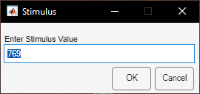

Figure 6. Stimulus value selection dialog

- Manually Assign Stretch Timepoints: The application assumes that the tissue is stretched 8 times consecutively, and it tries to automatically detect these stretches. This detection is necessary to segment the data into individual stretches. If there are fewer than 8 stretches or if the program fails to detect the correct stretch timepoints, then the user can manually define these points. They can do this by clicking File Format>Stretch Timepoints, and this causes a dialog box with 9 data entry boxes to appear. The ‘Enter Stretch # Start Time’ are the times (i.e., line numbers) when the stretches 1-8 occur. If data contains fewer than 8 stretches, users should enter ‘0’ in all the extra entry boxes (see Section 7 for more details). The ‘End Time’ should denote the line number at the end of last stretch.
For the sample data, the stretch and end times are:
5316; 65316; 125316; 185316; 245316; 305316; 365316; 425316; 515316.
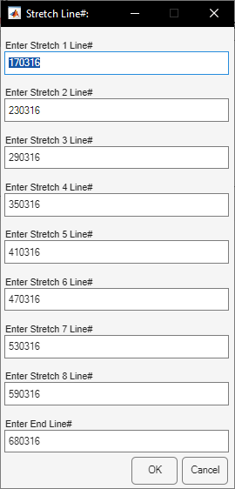

Figure 7. Manually assign stretch timepoints

- Initial Length (L₀ in mm): The initial gauge length of the tissue (see the manuscript text for more details on how to determine this) needs to be defined so that the percent stretch can be calculated. In the sample data, this value is 6.3 mm. The program will automatically record the length immediately before the first stretch occurs (from 5000 lines of data before first stretch). However, this can also be manually set. To keep all values in absolute lengths rather than relative lengths, set this value equal to 1.

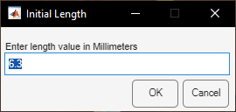

Figure 8. Initial length selection dialog
Section 6: Analysis of data with 8 stretches
This section will explain how to analyze the sample data included in the GitHub repository. In these experiments, the tissue was stretched in increments of 2.5% of L₀ 8 times, and the resulting force was measured. Section 7 describes how to customize the inputs for other experimental protocols.

- On the front panel, click the ‘Select Files’ button and locate the data file.
Note that the user can select multiple data files at one time to load them into the program.

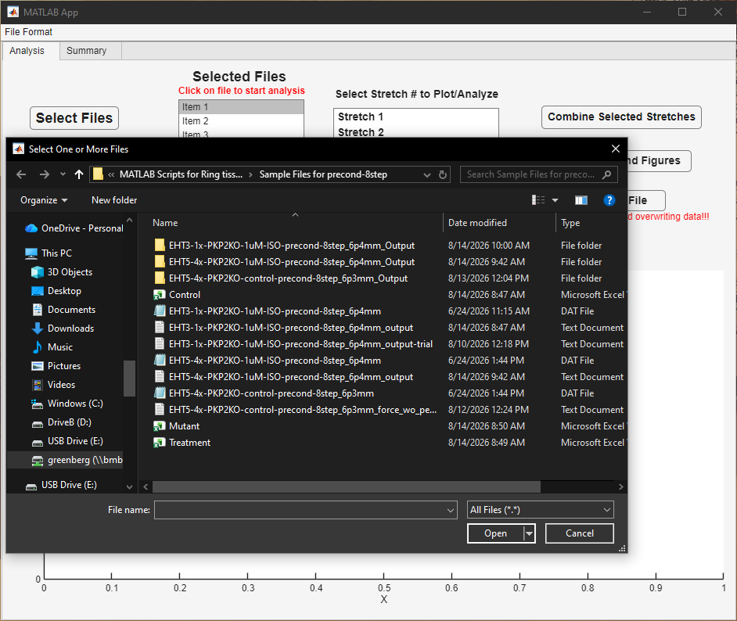

Figure 9. Selection of data files

- The selected files will be loaded, and their names will appear in the ‘Selected Files’ list box.
- Click on the name of the file that you want to analyze. This will highlight the name.

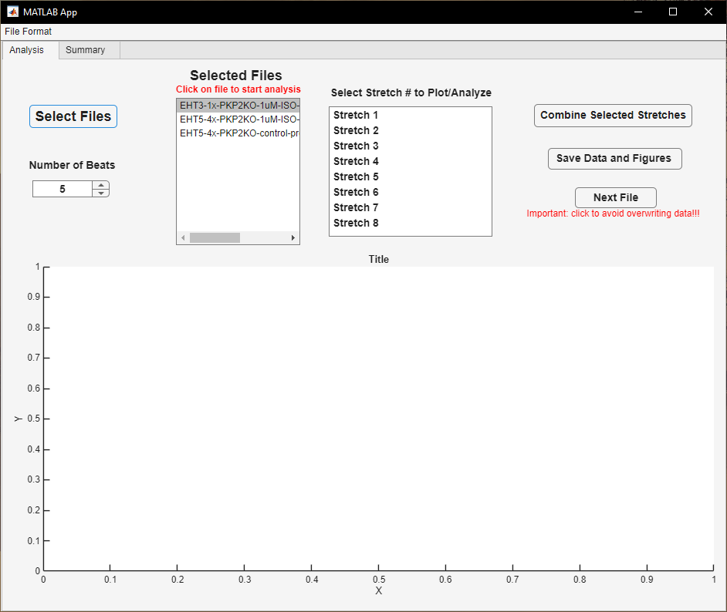

Figure 10. Selected files list box

- A pop-up window showing the length and force versus time for that file will appear. This allows the user to visualize and inspect the data before selecting and parsing through individual stretches.

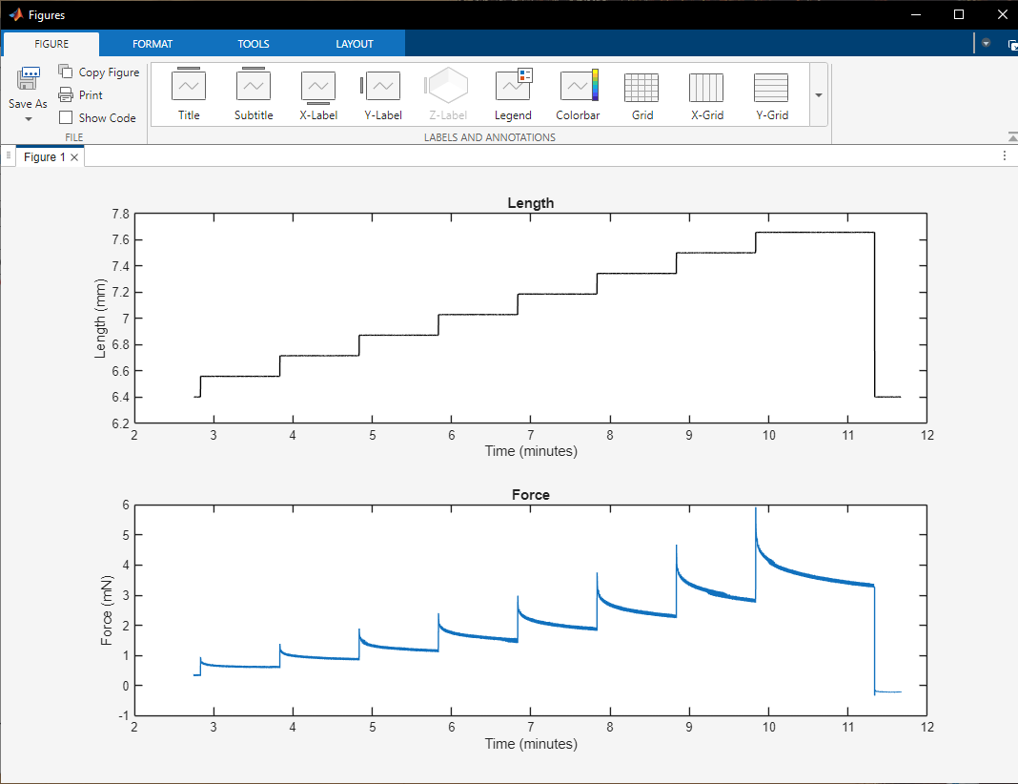

Figure 11. Length and force versus time plots
- For each stretch, the program averages several individual beats together for downstream calculations to ensure a good signal-to-noise ratio. The user should define how many individual beats to average together in for these calculations. The data entry box on the top left ‘Number of Beats’ is by default set to ‘5’, since in our experience, this is enough beats to get a good signal-to-noise; however, the user can change this number to suit their data.

Figure 12. Number of beats to average

- Now, the user can analyze each stretch in isolation. The box ‘Select Stretch # to Plot/Analyze’ lists the stretches identified in the data file (either automatically determined or manually defined by the user as in Section 5). Click on the stretch you want to analyze (e.g., Stretch_1). Note that the order in which the stretches are analyzed does not matter. The program will automatically organize the data by the order of stretch.

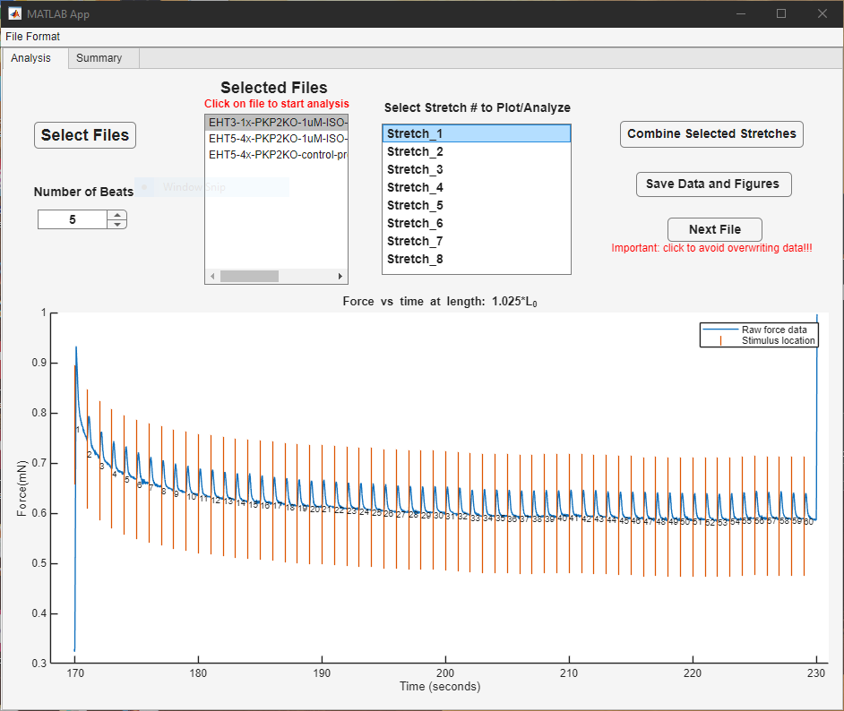

Figure 13. Select stretch # to plot/analyze list box

- The plot showing the force as a function of time will appear on the front panel, where the force trace is shown in blue. The orange lines show where the electrical stimulus occurred. There is also an index number assigned to each beat that is used for beat selection (below). Users can zoom in on the plot and/or pan through the plot as necessary. To access these controls, click on the three dots on the far right of the panel, above the plot. To zoom, click the magnifying glass icon. To return to the original zoom, click the house icon. To pan, click and drag.

Figure 14. Front panel view of beat selection

- The pop-up window allows the user to specify which beats they want to include in the analysis. The specific beats can be referenced by their index number on the force versus time plot (Fig. 14). Care should be taken to 1): only select beats with a normal waveform and 2): select beats after most of the viscoelastic relaxation has taken place (i.e., the baseline is stable). Typically, we use the last 5 beats at the end of a stretch, since the baseline is most stable there. When the user is happy with the selected beats, they should click the button ‘OK’ to proceed with the analysis. The order of the selected beats does not matter, and the selected beats can be changed multiple times during the analysis.

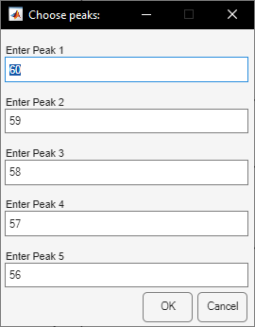

Figure 15. Choose peaks selection dialog

- A window will appear with 6 plots. These plots are:

Figure 1: Length and force as a function of time for the full trace (Fig. 11).

Figure 2: The force as a function of time for the selected beats in the stretch, where each beat is synchronized based on the electrical stimulus. Each colored line represents a different selected beat. Note that if the peaks look very different, it might be worthwhile to select different peaks for the analysis. As new stretches are analyzed, these appear as new subplots on the image.

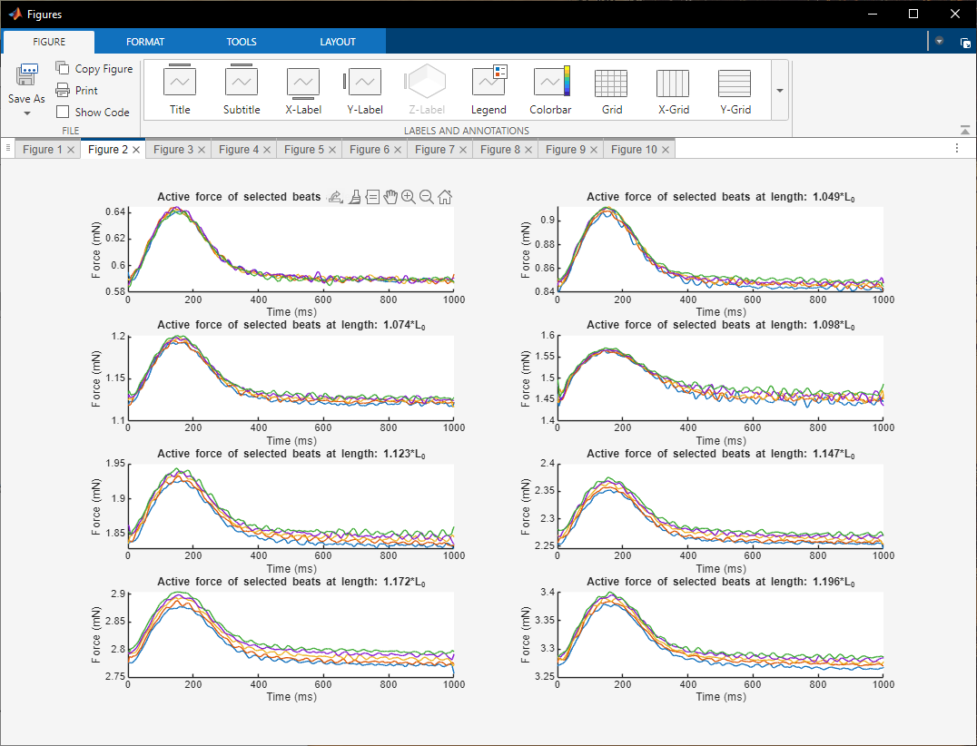

Figure 16. Averages of selected beats at different lengths

Figure 3: The average velocity of contraction and relaxation as a function of time obtained from averaging of the selected beats in the stretch. Beats are synchronized by the time of the electrical stimulation. Note that the velocity has units of force per time, not displacement per time, since force is measured (i.e., not displacement). A positive velocity occurs during contraction, and a negative velocity occurs during relaxation. As additional stretches are analyzed, these appear as different colored lines on the same plot.

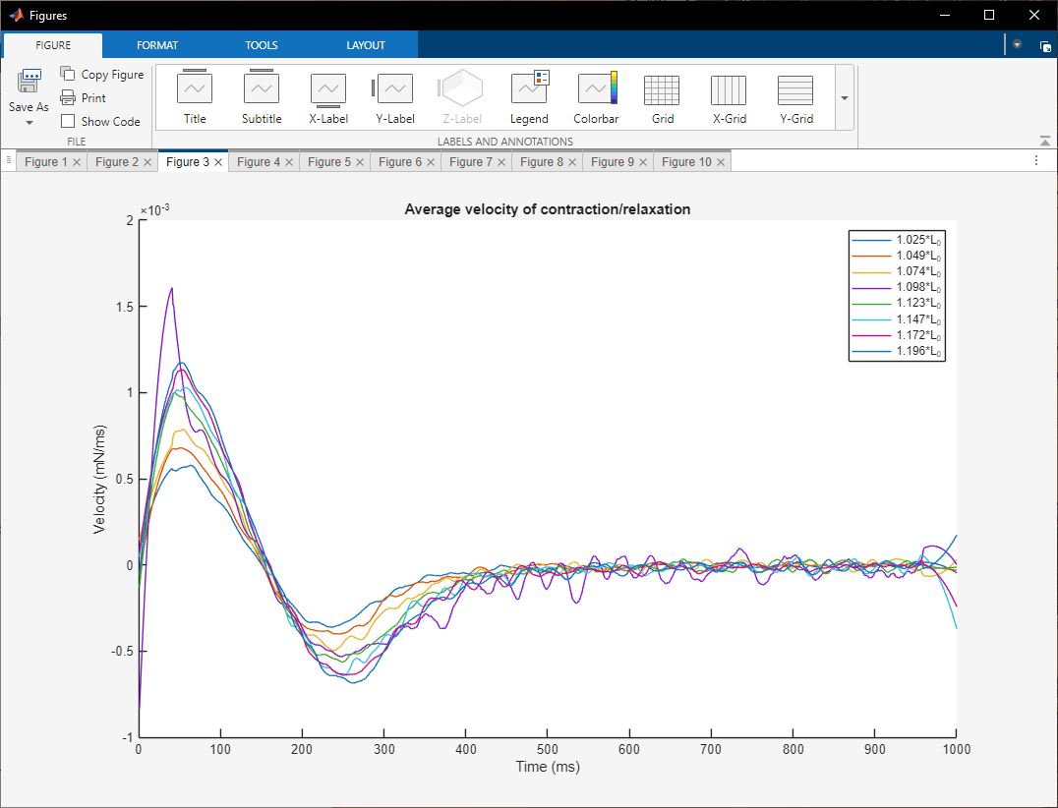

Figure 17. Average velocity of contraction/relaxation as a function of time

Figure 4: The average force as a function of time for the selected beats, synchronized on the electrical stimulation. There are several dots representing (from left to right): Time to 90% contraction, 75% contraction, 50% contraction, 50% relaxation, 75% relaxation, and 90% relaxation. As additional stretches are analyzed, these will appear as different colored lines on the same plot.

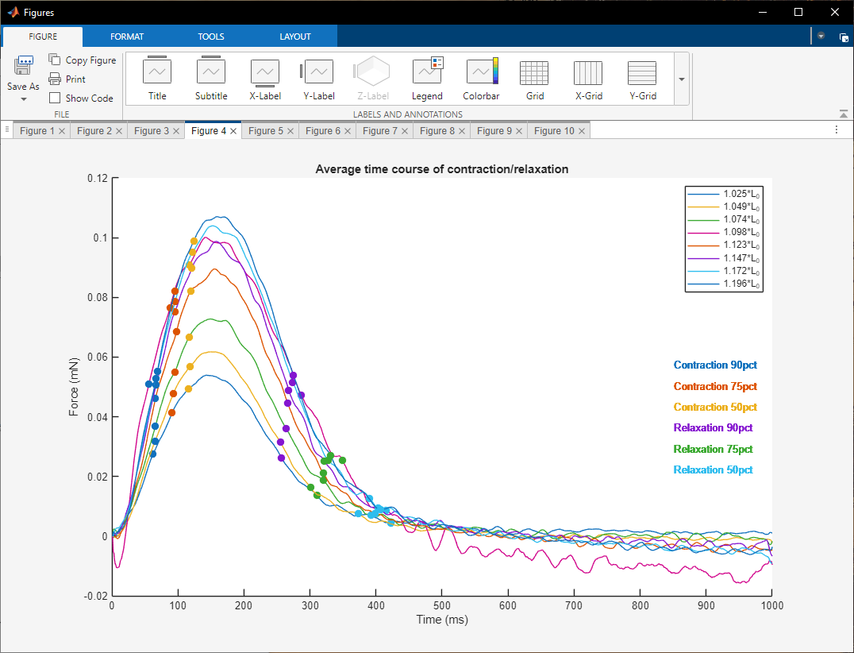

Figure 18. Average time course of contraction/relaxation

Figure 5: Poincaré plot showing a scatter plot to highlight beat-to-beat variability. The preceding interval between beats is plotted on the x-axis and succeeding interval between beats is plotted on the y-axis. A larger spread in the points on this scatter plot is associated with larger variability. To quantify the variability, an ellipse can be fitted to the data. The short-term variability is quantified by the spread perpendicular to the identity line, and the long-term variability is seen as spread in the points along the identity line. As additional stretches are analyzed, these appear as subplots.

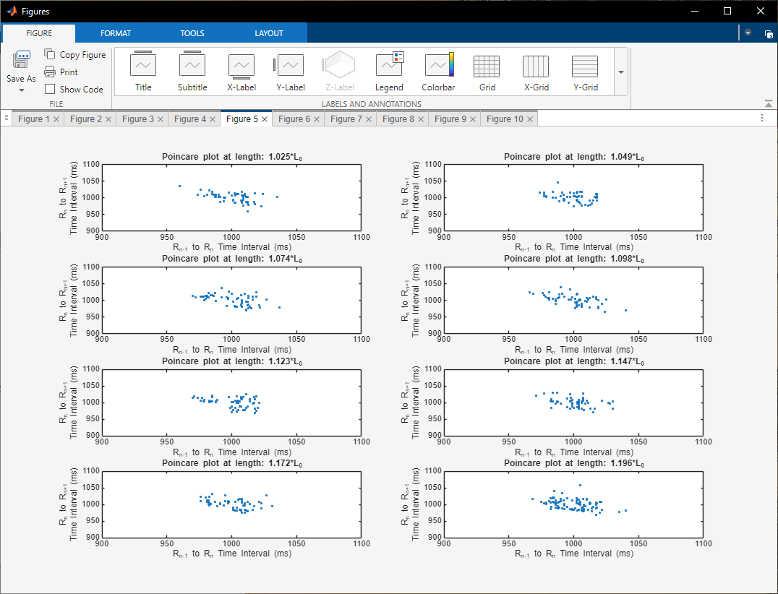

Figure 19. Poincaré plot at different stretches

Figure 6: The full-time course of force versus time for each stretch. The blue line shows force, orange vertical line marks the stimulus location, and the yellow line shows force with the active beating removed. As additional stretches are analyzed, these appear as subplots.

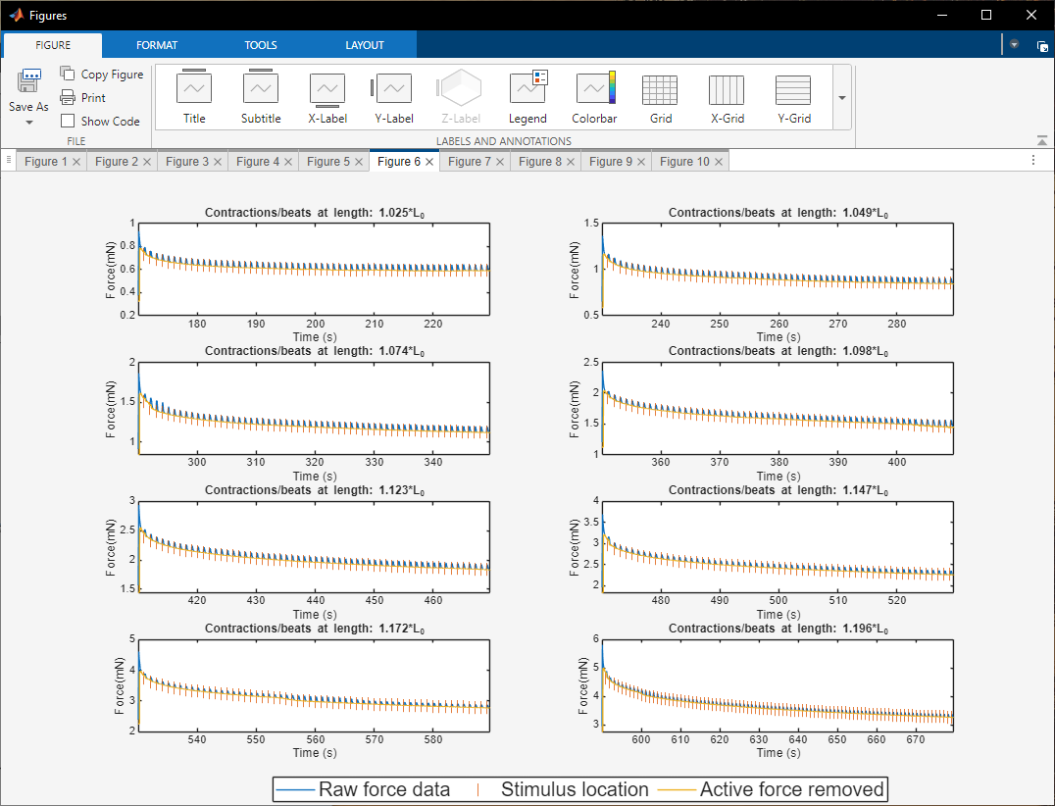

Figure 20. Force versus time data for each stretch

- Repeat steps 6-9 to process all the stretches.

- Once all the stretches have been analyzed, click the button ‘Combine Selected Stretches’. This will generate summary plots.

Figure 21. Combine selected stretches button on the front panel

The following summary plots will be generated:

Figure 7: The full force versus time trace with the active force of beating included (blue) and removed (orange). The blue line shows force, and the orange line shows force data with contractions/beats removed.

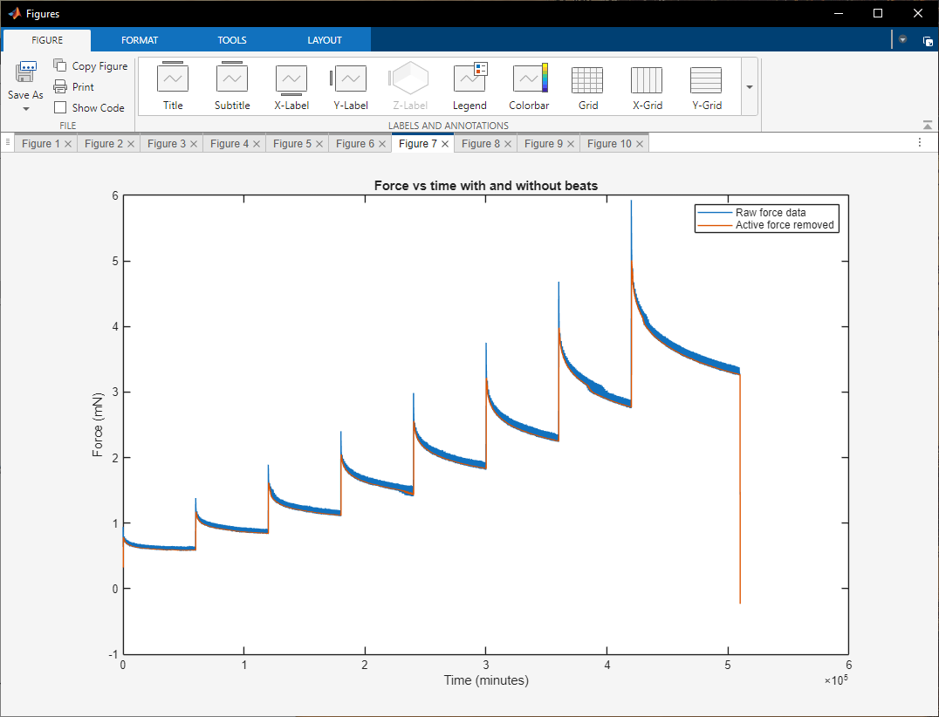

Figure 22. Force versus time data with and without peaks

Figure 8: The active force of beating as a function of stretching. Each point shows the average peak active force generated at a given stretch length. A quadratic function is fitted to the data to guide the eye.

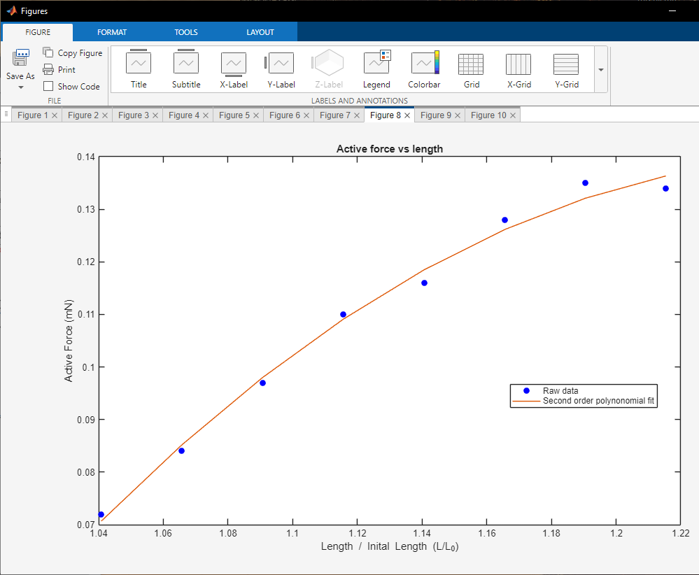

Figure 23. Active force versus stretch

Figure 9: The passive force as a function of stretch. Each point shows the average baseline passive force generated at a given stretch length. A quadratic function is fitted to the data to guide the eye.

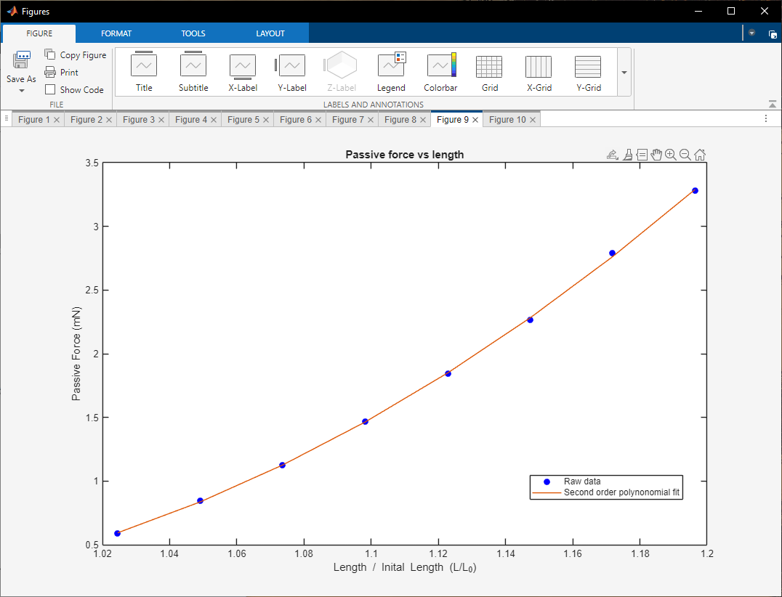

Figure 24. Passive force versus stretch

Figure 10: Poincaré plot for all contraction/beats. This pools all the intervals together. The short-term and long-term variabilities are calculated from the fitted ellipse.
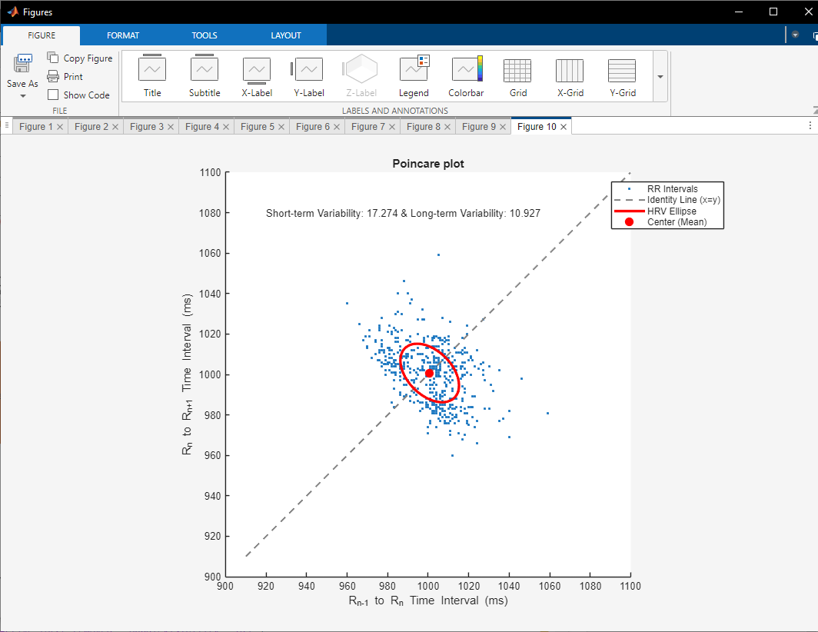

Figure 25. Poincaré plot pooling all stretches

- The data can now be saved by clicking ‘Save Data and Figures’. This creates a tab delimited file with the summarized data, csv file with average time traces, csv file containing relaxation with active beating removed, and separate files for the figures.

Figure 26. Save data and figures button on the front panel

- Summary output data file is saved in the current folder as ‘<data_file_name>_output’ as a tab delimited txt file. Each row has data from corresponding stretches. The columns shown in the file are:
Column 1: Length (mm)
Column 2: Passive force (mN)
Column 3: Active force (mN)
Column 4: Beats per minute
Column 5: Time to contract by 90% (ms)
Column 6: Time to contract by 75% (ms)
Column 7: Time to contract by 50% (ms)
Column 8: Time to relax by 90% (ms)
Column 9: Time to relax by 75% (ms)
Column 10: Time to relax by 50% (ms)
Column 11: Maximum contraction velocity (mN/ms)
Column 12: Maximum relaxation velocity (mN/ms)
Column 13: Force integral (mN * s)
Column 14: Work (mN * mm)
Column 15: Short term beat variability (SD1)
Column 16: Long term beat variability (SD2)
Column 17: SD12 (SD1/SD2 ratio)
If fewer than 8 stretches were analyzed, these will appear as NaN in the file.

- Output data– Two files are saved
1) the force data with active force removed saved as ‘_force_wo_peaks_data.csv’.
2) the averages of selected beats at each length saved as ‘_average_selected_beats_per_length.csv’
These are saved in a separate folder within the current folder created with the same name as data file and ‘_Output’ appended.

- All the generated figures are saved in both .png and .eps formats in the same folder as in (12b) above. The following figures are saved:
<data_file_name>_active_force_vs_length
<data_file_name>_average_selected_beats_per_length
<data_file_name>_avg_time_course
<data_file_name>_avg_velocity
<data_file_name>_force_data_w_and_wo_peaks_per_length
<data_file_name>_force_data_w_and_wo_peaks
<data_file_name>_length_and_force
<data_file_name>_passive_force_vs_length
<data_file_name>_poincare_plot
<data_file_name>_poincare_plot_per_length
<data_file_name>_selected_beats

- Once all data is saved for the current file, click ‘Next File’. This closes all active figures and erases data stored in memory from the current workspace.
Once this is done, it cannot be undone; however, this step is essential since failure to click this button before proceeding will result in files and figures getting overwritten.

Figure 27. Next File button on the front panel
Section 7: Analysis of data files with no stretches or fewer than 8 stretches
The program can handle files with 0 to 8 stretches, with some minor adjustments. If more than 8 stretches are used, the user can either: 1) modify the MATLAB code or 2) break their data files into smaller pieces with fewer than 8 stretches, analyze these separately, and then combine the data after.

- If the experiment has less than 8 stretches, the user should enter the row numbers of the 5 stretches as well as the final row to analyze. All other values should be set to 0 (in this example, there are 5 stretches):

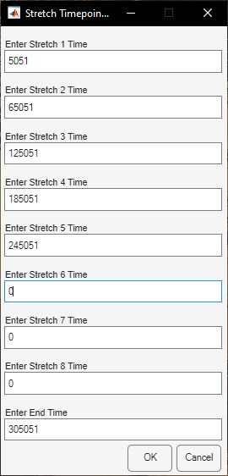

Figure 28. Example showing manual assignment of 5 stretch timepoints

- If your experiment has one stretch or no stretches, the user should edit the file as follows:

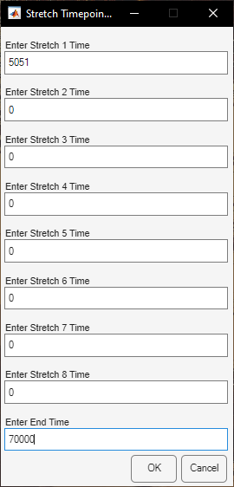

Figure 29. Manual assignment of a file with a single stretch

Section 8: Summary Tab
After analyzing several data files, it is possible to view summary plots of the data from multiple conditions.
Clicking on the ‘Summary’ tab reveals the summary panel.

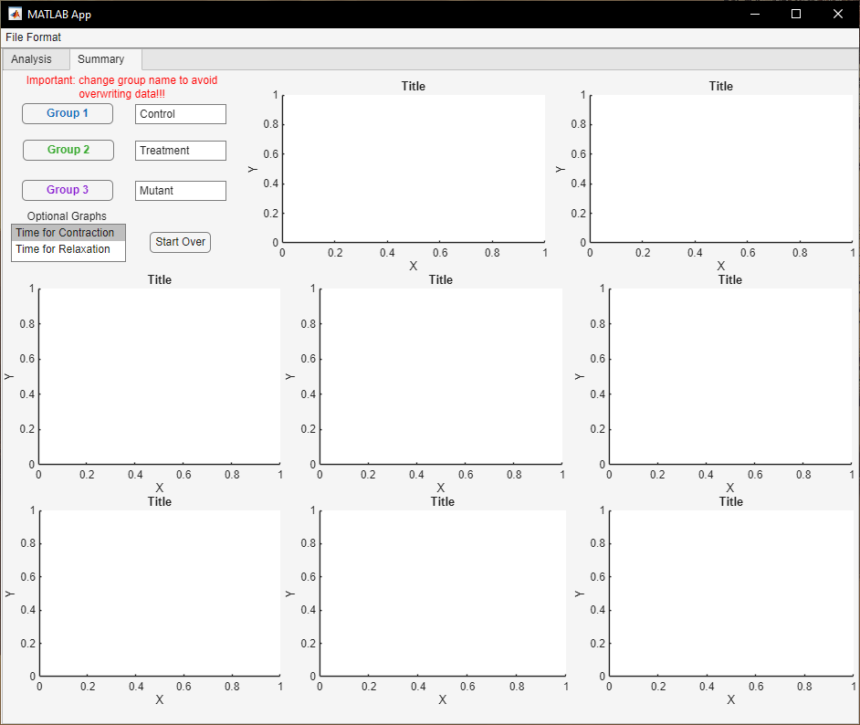

Figure 30. Summary tab

The buttons on ‘Summary’ tab are:
Group 1 – Clicking this button allows the user to select all ‘<data_file_name>_output’ files belonging to same experimental condition.
‘Control’ text box – The user can label the experimental condition however they wish. The final output summary excel spreadsheet file will label the data with this name.
Group 2 – Clicking this button allows the user to select all ‘<data_file_name>_output’ files belonging to same experimental condition.
‘Treatment’ text box – The user can label the experimental condition however they wish. The final output summary excel spreadsheet file will label the data with this name.
Group 3 – Clicking this button allows the user to select all ‘<data_file_name>_output’ files belonging to same experimental condition.
‘Mutant’ text box – The user can label the experimental condition however they wish. The final output summary excel spreadsheet file will label the data with this name.

There are 8 figure boxes on the panel. These will be populated with the median values from the output files. Data are fitted with quadratic functions to guide the eyes. Colors appear the same as the buttons.

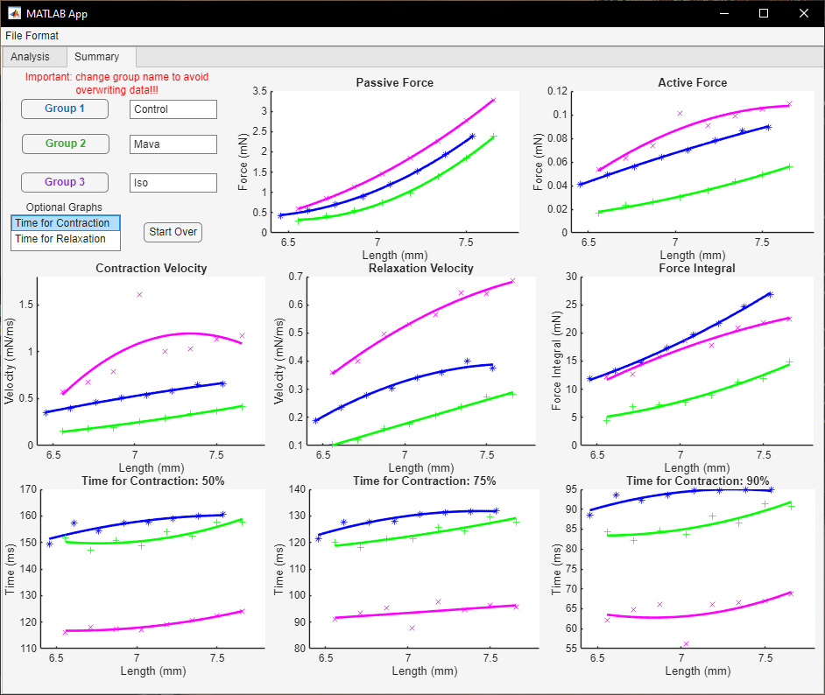

Figure 31. Summary tab output

Optional graphs list box: This allows the user to plot either the times for contraction or times for relaxation for the desired conditions.

Start Over – This clears the existing workspace and figures.

The program automatically generates excel spreadsheets summarizing the data from files selected per condition. The file is named with the user assigned group names (e.g., Control/Treatment/Mutant). The file contains subtabs with the following parameters: length, active/passive force, beats per minute, times and velocities for contraction/relaxation, force integral, work, and the Poincaré plot parameters SD1, SD2, and SD12 (ratio of SD1/SD2).

